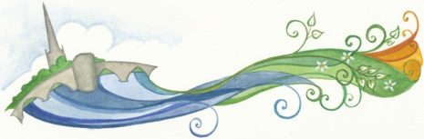

EQUALITY STATEMENT for St Ives in Bloom
October 2025

The Committee of St Ives in Bloom is committed to providing opportunities for volunteering to all potential volunteers without discrimination on grounds of age, disability, gender, race, religion or belief, sexual orientation or other characteristics.

Signature of Chair: _____________________________________

Date of signature/ratification of statement: 14th October 2025

______________________________________________________________

Date that next review is due: October 2027

