Meeting Notes
‘ST IVES IN BLOOM’ ANNUAL GENERAL MEETING
held at The Corn Exchange
at 7.30pm on 28th September 2015

Present: 2014/15 committee members:
Marney Hall (Chairman)
Moreen Wells (Vice Chairman)
Hattie Grimwade (Secretary)
Colin Saunderson (Treasurer)
Linda Croucher (Garden Club)
Jude Ongeri (Resident)
Jill Burt (Friends of Holt Island)
Peter Baker (Town Team/Civic Society)
Robin Bletsoe (Hill Rise Allotments/Garden Club)

Also present:
Ian Jackson (St Ives Town Council)
Margaret Smith (Resident)
Julie Pepper (Resident)
Helen Tiddy (Resident)
Maggie Dale (Resident)

APOLOGIES  Apologies for absence were received from Ryan Fuller, Pam Edey and Hayley Weightman.  1. CHAIRMAN’S ANNUAL REPORT  Marney presented her report to the Committee (attached, Appendix 1). In summary it was agreed that the much greater effort and community participation this year had not been reflected in an improved result, as other areas (horticultural achievement and environmental responsibility) must have received fewer marks from the judges. There is a feedback session on November 12th, when participants will be given full details.  Marney thanked many members of the committee for their hard work both as fundraisers and with the planting and weeding parties, and asked that messages of thanks should also be passed on to the partners of committee members! Both Moreen and Hattie were presented with gifts as thanks for their efforts last year.  Marney explained that if we were to enter next year and improve our results, we would have to work more closely with the horticultural team on the Town Council and also try to encourage more volunteers for our new projects and regular responsibilities. Continuing discussion about whether to enter in 2016 took place during the next item.  2. PRESENTATION OF ANNUAL ACCOUNTS  Colin Saunderson presented the Annual Accounts (attached, Appendix 2) showing expenditure in the current financial year. Colin explained that there was a difficulty with 31st March year end, which meant he had shown the fees for 2015 entry (actually paid before 31st March) in 2015 in the Town Council account. He also explained that the high price for the website was to do with a new site being set up in 2014 and that there is also now a photocopying charge from the Town Council. (When the Secretary was based in the council offices in 2014 there had been no itemisation of photocopying, nor separate charges for stationery or printing.) There has also been more photocopying activity (e.g. letters for fundraising and draft copies of the portfolio were produced this year).  Robin asked Colin to identify the financial cost of entering Anglia in Bloom, and there followed a discussion about whether the benefits of being in the competition was worth the expenditure. Colin explained that the entry fee for the main competition had increased this year to £150, and that we had entered Broad Leas cemetery at a further cost of £30. The costs for three members of the committee to attend the awards ceremony had been paid for out of St Ives in Bloom funds (£78). There were also costs involved in producing the portfolio and in entertaining the judges in July.  Linda asked whether we would receive a council grant if we did not go in for the St Ives in Bloom competition, and Marney replied that she had been told previously that the grant was dependent on the competition entry. (Later in the meeting Ian Jackson (Town Council) said that he would check whether this would still be the case, as building volunteer support was now an agreed council aim.) There was a feeling among some volunteers and committee members, voiced by Helen, that ‘aiming for gold’ had helped give a target and impetus to the work that had been undertaken this year. Peter said that we could not make a decision about entering Anglia in Bloom until after the feedback session with the judges, and that further discussion and a final decision should be postponed until the November meeting.  Robin proposed that the Accounts should be approved and this was seconded by Peter. The annual accounts were AGREED unanimously. Marney thanked Colin for preparing them.  3. ELECTION OF OFFICERS  3.1 APPOINTMENT OF CHAIRMAN  Marney Hall agreed to continue as Chairman for the coming year. She was proposed by Robin, seconded by Linda and elected unanimously.  3.2 APPOINTMENT OF VICE CHAIRMAN  Moreen is standing down as Vice Chairman, although she will continue as a work party volunteer. Marney proposed Linda Croucher as her successor, and this was seconded by Jude and she was elected unanimously.  3.3 APPOINTMENT OF TREASURER  Colin Saunderson agreed to serve for another year as Treasurer. He was proposed by Robin, seconded by Linda and was elected unanimously.  3.4 APPOINTMENT OF SECRETARY  Hattie Grimwade agreed to continue as Secretary for the coming year. She was proposed by Linda, seconded by Jill, and was elected unanimously.  4. MINUTES of AGM, 20th October 2014  Marney reviewed the minutes of the AGM held on 20th October 2014 and they were agreed as a correct record.  It was agreed to go ahead with the projects decided on for this term. There was some discussion about the local competitions – and especially that we should try to encourage more entrants in the garden competition. Margaret explained that people could be put off entering if their level did not improve – and it was suggested that people should be informed of the judging criteria.  Marney explained the responsibilities of paid workers within the Town Council and the District Council, and how their input was also reflected in the scoring system for Anglia in Bloom. The work completed in Broad Leas cemetery was discussed. Hattie explained that some volunteers were keen to continue clearing ivy from some of the graves in the coming year, but that this was an example where we could not improve on our ‘In Bloom’ level in the cemetery category (silver this year) with only volunteer involvement.  Committee members were again reminded of the dates and times that Robin has arranged for planting bulbs: Saturday 10th October outside Wheatfields and Saturday 24th October at the junction of Pig Lane and Warren Road.  5. MATTERS ARISING FROM MINUTES of last MEETING, July 2015  There were no matters arising from the July meeting minutes, and they were passed as a correct record.  7. DESIGNATION of COMMITTEE MEMBER RESPONSIBILITIES  The Committee members for 2015/2016 were confirmed and listed overleaf (their responsibilities identified in blue):  - Volunteer coordinator: Hattie Grimwade  - Publicity: Hattie Grimwade  - Website: Hattie Grimwade  - Portfolio: Hattie Grimwade  - Link, St Ives Town Council: Pam Edey  - Link, St Ives Garden Club: Robin Bletsoe  - Link, HRAA: Jude Ongeri  - Link, Friends of Holt Island: Jill Burt  - Link, Civic Society: Peter Baker  - Link, Town Team: Margaret Smith  - Link, St Ives Retail group: Pam Edey  - Link, St Ives Town Initiative: Ryan Fuller  - Link, Schools: Robin Bletsoe  - Link, Huntingdonshire District Council: Ryan Fuller  - Residents: John Kennedy, Julie Pepper, Maggie Dale  (Hattie explained that she would be pleased to share her responsibilities, and would support committee members in a new role if they could consider getting more involved either as meetings secretary or any of her other roles above.)  8. ATTENDANCE at ANGLIA in BLOOOM FEEDBACK, NOVEMBER 12th  Marney explained that she was unable to go to the Anglia in Bloom feedback in November, and there was a request for volunteers. Pam had sent a message that she is able to go, and as a minimum Moreen and Robin will go with her. Attendees and details will be finalised at the next meeting, and the final decision on entering Anglia in Bloom 2016 will be taken after that.  9. ANY OTHER BUSINESS  Colin and Robin reported on the schoolchildren’s enjoyment of their growing competition and the Flower and Produce Show. The exhibition put together by children from Westfield School has now been moved to the Library, and will be there until mid-October.  Colin informed the meeting that Huntingdon Town Council is reported to be negotiating with the District Council about responsibilities for flower beds in the town.  Marney had asked Ian Jackson (Town Council Mayor) to come and speak. He thanked committee members and volunteers for their hard work this year, and stated his appreciation for both the committee’s and the volunteers’ work to improve the environment of the town. He also promised the support of the Town Council for a further attempt in the Anglia in Bloom competition, if the committee decided to go ahead with this.  10. NEXT MEETING  Monday 12th October at 7.30pm in the Golden Lion.  Appendix 1: Chairman’s Report  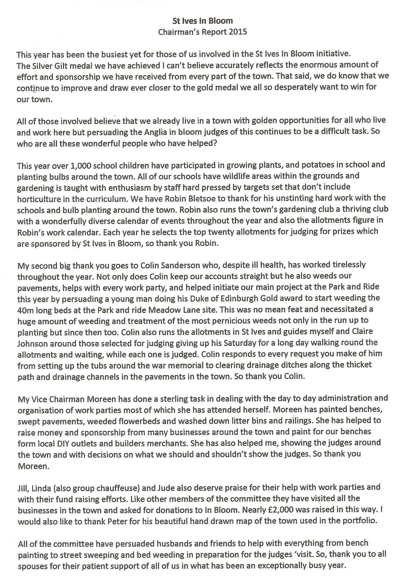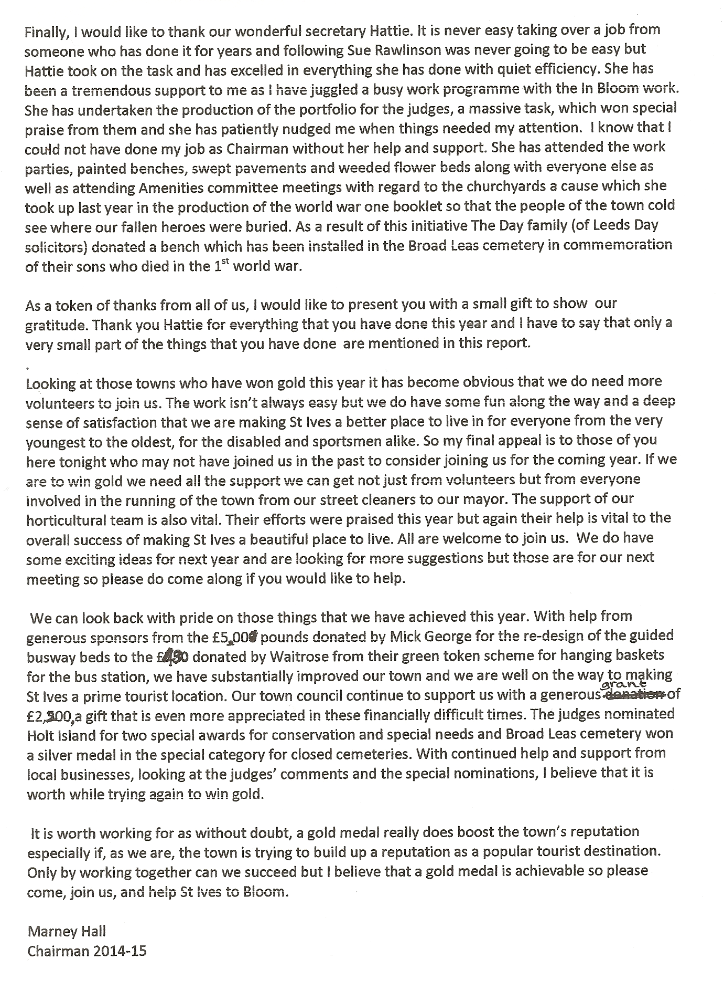  Appendix 2: Accounts | Action  PE  (through IJ)  HG  ALL  PE, MW, RB,  + others?
