Meeting Notes, ‘ST IVES IN BLOOM’
held at The Golden Lion at
7.30pm on 11th January 2016

Present: Linda Croucher (Vice Chairman)
Hattie Grimwade (Secretary)
Robin Bletsoe (Gardening club)
Ryan Fuller (SITI, HDC)
Jill Burt (Holt Island)
Moreen Wells (Resident)
Margaret King (Town Team)

- Apologies were received from: Marney Hall, Colin Saunderson, Pam Edey, Jude Ongeri, Peter Baker  - Report from meeting with Town Council (appendix i). Items discussed in particular were:  - Item 3.4: We will keep in contact with the Town Council team, and let them know in advance if, for instance, we were going to weed on the Waits.  - Item 4.5: The committee welcomed the chance to trial a change in grass management for a section of Broad Leas cemetery, and look forward to liaising with the Amenities Committee about the exact area proposed.  - Item 4.7: There was some disappointment expressed that the improvement to the planting in Sheep Market with a “herb wheel” is not planned until 2017 – Robin had explained the concern that it would not match with the red, white and blue scheme proposed.  - Item 4.8: HDC had not issued a licence for the hanging baskets in the Bus Station – we will wait to hear from the District Council before planning for their use in another area if necessary.  It was further resolved that a list of requests for maintenance to be completed before the judges’ visit should be finalised at the next meeting and submitted to the Amenities committee for their information in February – committee members are asked to check on street furniture etc. and bring any concerns to the next meeting.  - Report on meeting with John Souter of the Town Team about roundabout improvement (appendix ii). Margaret will report on our discussion to the Town Team, with three items in particular:  - It was agreed that Hattie would order cowslips and primroses from the supplier identified last year and that we would arrange a date for planting on the verge by roundabout 21 (see item 7c).  - Concern was expressed that the Seven Wives roundabout would be a confusing name given that the pub is at the other end of town, and that it may be better called The Meadow roundabout.  - Ryan reminded the committee of the problems encountered previously – that the sponsors already identified on the roundabout contribute to maintenance only. The Town Team is planning to raise sponsorship for the several thousand pounds needed to implement new designs – but those sponsors would not necessarily be the ones already paying to have their names on the signs. It was felt that we were at an early stage in the discussions, and that at some point the maintenance sponsorship must in any case come up for renewal, so that this should not stand in the way of long term planning by the Town Team.  - Discussion of advertising hoarding at town bus station. Following Jude’s email about the advertising hoarding over the flower bed in the Bus Station, Ryan got in touch with the planning department. Discussion of the legal position followed, and the Planning Enforcement Officer reached an amicable compromise with the director of Hyperion, whereby she will put up the banner only for the day of an auction. The committee was pleased with this resolution.  - OTHER MATTERS ARISING from November minutes  - Plaques for wooden tubs outside the Parish Church: Jill reported that, after taking advice, she is ordering stainless steel plaques to be put on the tubs.  - Report on application to Mick George (Park and Ride planters): Hattie reported she had submitted the application (with detailed costings by Marney) to Mick George in December. Once we have the result of that application, Hattie will arrange a meeting with the new Busway maintenance company and Robin agreed to represent St Ives in Bloom. He explained the plan to plant wildflowers in the area around the offices and toilets.  - Octagon building. Ryan reported that HDC are repairing/tidying the building ready for community use, but that it was too early for St Ives in Bloom to get involved in any plans for gardens etc.  - DRAFT ROUTE FOR JUDGES. The draft route was distributed and some changes made, with question marks only over the ‘biodiversity award’ category – the two areas under discussion being Tenterleas and The Thicket. The rest of the route was agreed and all committee members were asked to make sure they have looked at it before the February meeting when it will be finalised (appendix iii). Three further items were debated:  - The difficulties of improving the area around Kings Hedges were discussed, and in the end it was resolved to ask the Town Council for permission to attach a flower trough to their new noticeboard there.  - Jill will ask the Friends of Holt Island whether we can have a social lunch for the judges there, with gazebos borrowed from the Town Council if possible. She will start to investigate the different catering possibilities.  - Robin will invite The Merchant House to be put forward for the Anglia in Bloom award. Other pubs and restaurants put on a good display, and they will be invited to enter our locally run competition.  - ANY OTHER BUSINESS  - War Memorial troughs: Marney has replanted the troughs by the war memorial with an attractive display. However, members of the public, the Civic Society and the SIiB committee have commented that the troughs are unsuitable, only being made of plastic. It was suggested applying to Waitrose community matters to fund more fitting troughs, at a cost of around £150 each, and this and other possible sources of funding were discussed. Ryan confirmed that this project would be suitable for an application to the Huntingdon District Council “Community Chest” scheme which has a June/July deadline. It was suggested that we therefore delay our request to be part of the Waitrose community matters scheme until next year.  - Other SIiB troughs in town: Linda explained that she is also planning for a better quality of troughs or planters outside the Free Church, so that the display can be more striking this year. It was agreed that she should price and buy better planters, and this will also free up some of last year’s planters for use in other areas.  - Young people’s project: Moreen will talk to Colin about the possibility he mentioned of help from the football club, and work with him to see if they can be involved in one of our projects this year.  - Dates for volunteer work parties: The following dates were set for work parties, with the proviso that if it is cold or wet they will be cancelled until a more suitable time:  Tuesday 26th January, 10 - 12: Broad Leas Cemetery, cutting back ivy;  Tuesday 9th February, 10 - 12: Broad Leas Cemetery, cutting back ivy and planning for spring planting in area designated by Town council (item 2b);  Thursday 10th March, 11 – 1pm: Westwood Road Cemetery, preparing area for planting by Eco Ivo school group at 1.30  (Thursday 24th March, reserve date for above);  Tuesday 22nd March, 10 – 12: planting cowslips on the verge by Jones boatyard, opposite roundabout 21 (see appendix ii).  - DATE and TIME of NEXT MEETING  A timetable for future meetings (appendix iv) was given out, and it was agreed that the next meeting will be held on:  Monday 8th February,  at 7.30pm in the Golden Lion.  St Ives in Bloom, c/o Town Hall, Market Hill, St Ives PE27 5AL  www.stivesinbloom.co.uk  Appendix i  Report to Amenities Committee, 25th November 2015  AGENDA ITEM: A  SUBJECT: In Bloom Meeting Report  1 Introduction and Purpose of Report  1.1 A request was received from In Bloom to meet with the Amenities Chairman, Town Clerk and Ground Maintenance Supervisor to discuss a closer working relationship in the run up to the 2016 competition  2 Recommendations  2.1 The report is received and content noted  2.2 Agreement is given to allowing a small area of Broadleas Cemetery to be set aside for some natural planting and grass growing as a trial during spring and summer 2016.  2.3 Agreement is given to a ‘red, white and blue’ colour scheme for next year’s summer planting that incorporates bee and butterfly friendly flowers where practical.  3 Background  3.1 Following the disappointment of once again not gaining a ‘gold’ in the Britain in Bloom completion this year the In Bloom Committee have committed to enter again for 2016.  3.2 To this end they have requested a closer working relationship with the Town Council in order to achieve this.  3.3 At the start of the meeting the Chairman of In Bloom expressed her personal and the groups sincere thanks to the Ground Maintenance Team for the hard work that they put into the open spaces in St Ives – especially in the lead up to the judging day in the summer.  3.4 The Town Clerk confirmed to the In Bloom reps that a closer working relationship would be welcomed and that there were elements of the maintenance of the councils opens spaces where volunteer assistance would be much appreciated. However she stressed that ‘guerrilla gardening’ would not be tolerated and that it caused bad feeling in the past. The Chairman confirmed that the group did not support ‘guerrilla gardening’ and would discuss this with the group as a whole at the next meeting.  4 Proposal  4.1 A themed planting scheme is included for the spring and summer planting carried out by the Town Council that includes bee and butterfly friendly flowers. Following discussion it was agreed that ‘red, white and blue’ would be appropriate to celebrate both the Queens 90th birthday but also the Olympic Games to show support for the UK team.  4.2 More concentrated planting is on the Waits was introduced that catered for the differing conditions (full sun/full shade/drier areas under trees). It was agreed that geraniums should be used under the trees as they could cope with less moisture and more shade.  4.3 The planter under the town sign on Harrison Way be removed and re-used on the ‘Old Riverport’ sign at the corner of Needingworth Road. The current location was under trees and the flowers planted in it never thrived because of this. The Chairman of In Bloom agreed to maintain the planter in the new location as it was directly opposite her house and would prove difficult for the GM Team to water.  4.4 It was suggested that the other ‘Old Riverport’ signs should also have flower planters installed but following a discussion on the practicalities and costs of maintaining them it was agreed that this was not a sensible suggestion and should not be progressed.  4.5 An area to the south of Broadleas Cemetery that is not within the main section is left to grow naturally to facilitate the increase in natural flowers to grow. The section would be strimmed once in late summer and the In Bloom group would assist the GM Team to gather the resultant grass up to reduce the time required to maintain it. Should it prove to be unpopular with cemetery users it would not be continued into a 2017.  4.6 The GM team collect the resultant ‘ivy waste’ following the groups ivy clearing day on Wednesday 2 December.  4.7 The proposal for a sensory garden to be planted within one of the circular planters in Sheep Market would be progressed over the coming year with a view to implementing in 2017. It was also agreed that the clematis within the bed would be removed as it was not a suitable location for it.  4.8 It was agreed that should In Bloom receive the necessary licences from HDC then the Town Council would maintain the hanging baskets around the bus station again next year. The Town Clerk agreed to investigate the feasibility of having trough planters on the sides of the bus station toilets again.  5 Financial Implications  5.1 None  6. Policy Implications  6.1 None  7. Health and Safety Implications  7.1 None  8. Reporting Officer  8.1 Alison Melnyczuk, Town Clerk  Appendix ii  Sponsored roundabouts in St Ives area:  27  26  24  23  22  21  DRAFT PROPOSALS | Action  HG  MH  ALL  HG  JB  HG  RB  ALL  HG  JB  RB  LC  MW/CS  ALL
  Number | Where? | Present planting | 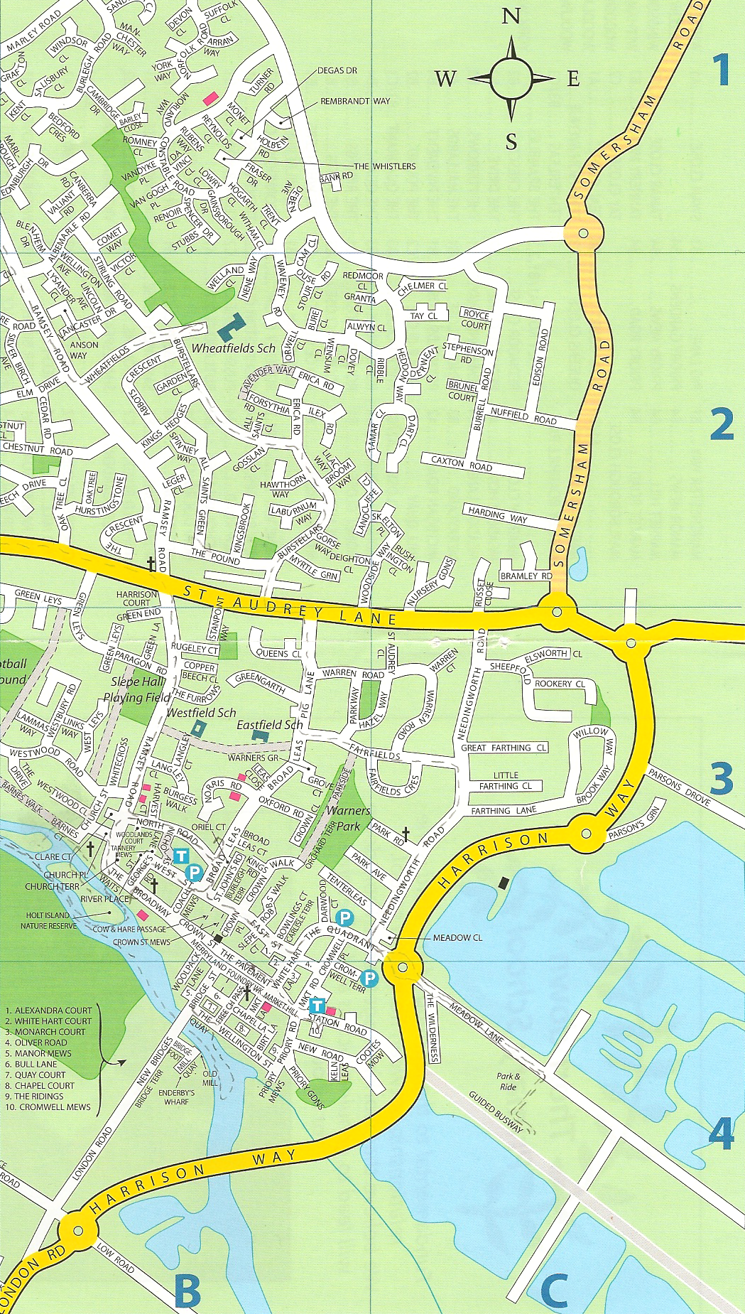Sponsored by
  Site 21 | Harrison Way/Low Road/ Hemingford | Shrubbery – slightly overgrown but good mix | Wellington Wise
  Site 22 | Harrison Way/ Meadow Lane/to Park and Ride | 7 wives (stone), 7 cats (catmint) on gravel. Notice to make clear what they represent? | Marshalls
  Site 23 | Harrison Way/ Parsons Green by Clare Hall and Sailing Club | Very neat areas of shrubs in low cut grass | Right Move
  Site 24 | A1123/Harrison Way/Stock Bridge Way/ by Compass Point Business Park/Silvaco | Very neat areas of shrubs in low cut grass | Lakeside Lodge golf & restaurant
  Site 25 | A1123/ Needingworth High Street /Golf club | Very neat grass, daffodils and some shrubs
  Site 26 | A1123/Somersham Road/by Tesco Express and Garage | Sage bushes outer circle round other shrubs. A couple of shrubs damaged – messier than other roundabouts. | Anglia fireplaces
  Site 27 | Somersham Road/ Marley Road/ by top of Industrial Estate | Mix of lavender, large leafed palm type and shrubs in neat grass | Wellington Wise
   | Design proposal by Marney Hall agreed at meeting with John Souter on 4th January
  Site 21 | Roundabout unchanged  ST IVES - OLD RIVERPORT SIGN on mast if possible  SIiB to plant cowslips on verge in front of Jones boatyard – Jan/Feb 2016
  Site 22 | Marketing Force to be requested to clear weeds from site by end of February,  Marney to oversee cutting back of catmint and addition of poppy seeds in March  ST IVES - SEVEN WIVES SIGN if possible
  Site 23 | New design “boat in waves of grass” to be completed, and request to go to Marketing Force and CCC by end of February  ST IVES - SAILING AND THE RIVER SIGN if possible
  Site 24 | New design “market animals”, with willow sculptures, request to go to Marketing Force and CCC  ST IVES – ANCIENT MARKET TOWN SIGN if possible
  Site 26 | New design “old toll house”, with hexagonal shape, request to go to Marketing Force and CCC  ST IVES – OLD TOLLHOUSE SIGN if possible
  Site 27 | Roundabout unchanged  ST IVES – CENTRE for NEW INDUSTRIES SIGN if possible
Appendix iii: see separate file, “Judges itinerary, 2016”

Appendix iv
St Ives in Bloom
TIMETABLE FOR MEETINGS until June 2016
JANUARY 11th:
- Draft plan of route for judges
- Setting dates and tasks for work parties, January and February
- Arrange meeting with Park and Ride maintenance team
- Initial planning promotions, sponsorship and publicity for 2016:
- Green token (Waitrose)
- Sponsorship stickers and contact with retail groups
- First draft roundabouts submission with Town Team
FEBRUARY 8th:
- Review plan of route for judges and finalise
- Promotions and publicity for 2016, including setting date for launch
- Start planning local competition – draft leaflet
- Planning for increased business involvement
- Setting dates for work parties, March and April
- Enter for St Ives in Bloom and discuss plans for expenditure from April
- Complete planning roundabouts submission with Town Team
- List of requests to Town Council re street furniture etc.
MARCH 14th:
- Planning for launch, finalise leaflet for local competition
- Request for photos and information for portfolio
- Promotions, sponsorship and publicity for 2016 – planning shop visits
- Contacts with other community groups
- Report on final budget for 2015/16
- Any plans for bulb planting in October?
- Submit final list of requests to Town Council
APRIL 18th:
- Complete plans for local competition and publicity
- Summer planting for War Memorial
- Summer planting for our garden on Waits
- Setting dates for work parties, May and June
- First draft portfolio
MAY 9th:
- Second draft portfolio
- First draft presentation to judges
- Review business, schools and community involvement, sponsorship amount
- Any extra dates for work parties, May, June and July
- Submit requests to Town Council re tidying and cleaning for the day
JUNE 13th:
- Finalise checks for summer display in town centre and judges route
- Final portfolio
- Final draft presentation to judges
JULY 4th: Last minute plans
END JULY: Review of the judges’ visit

